Deployment in Azure

1. Create new resource🡪 Web app in azure

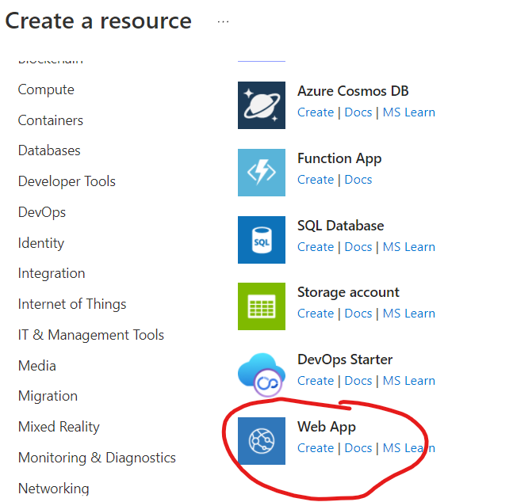

**Runtime stack: python 3.7**

**Create**

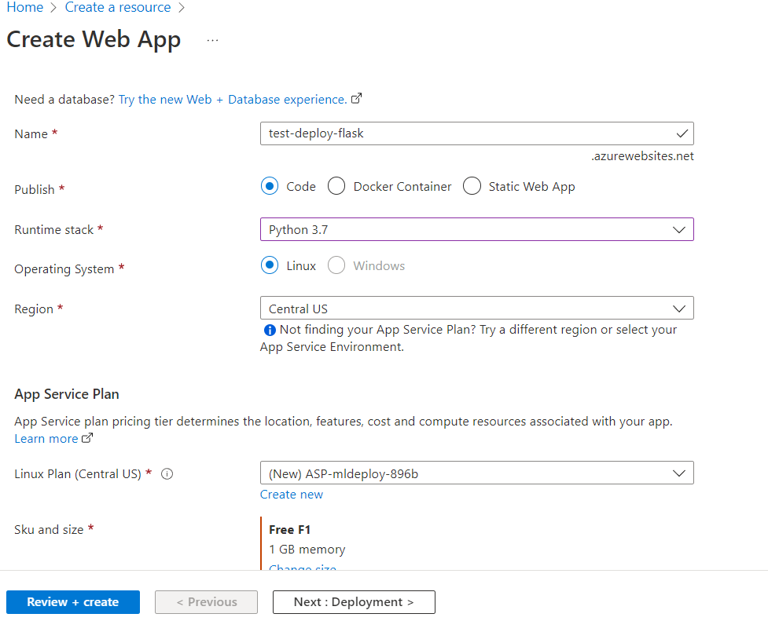

**Goto deployment center and give local git and save**

**Find git clone url in overview**

**Open cmd and go to the project path**

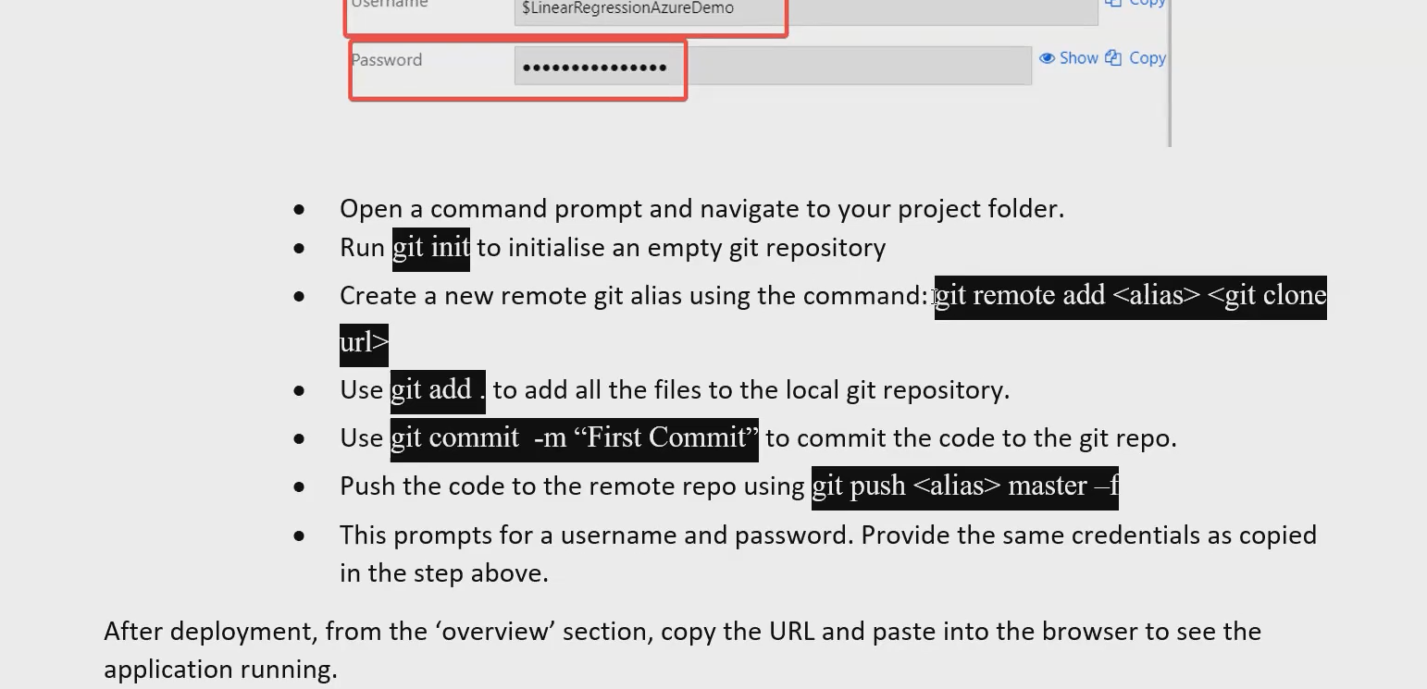

Username and password is deployment center.

If not able to change username which is null in popup, replace null in git clone url with username

git remote set-url <alias> <git clone url>

git remote set-url pred <https://$test-deploy-flask@test-deploy-flask.scm.azurewebsites.net/test-deploy-flask.git>

<https://docs.microsoft.com/en-us/azure/app-service/quickstart-python?tabs=flask%2Cwindows%2Cazure-portal%2Cvscode-deploy%2Cterminal-bash%2Cdeploy-instructions-azportal%2Cdeploy-instructions-zip-azcli>

**the name of the flask file should be app.py**

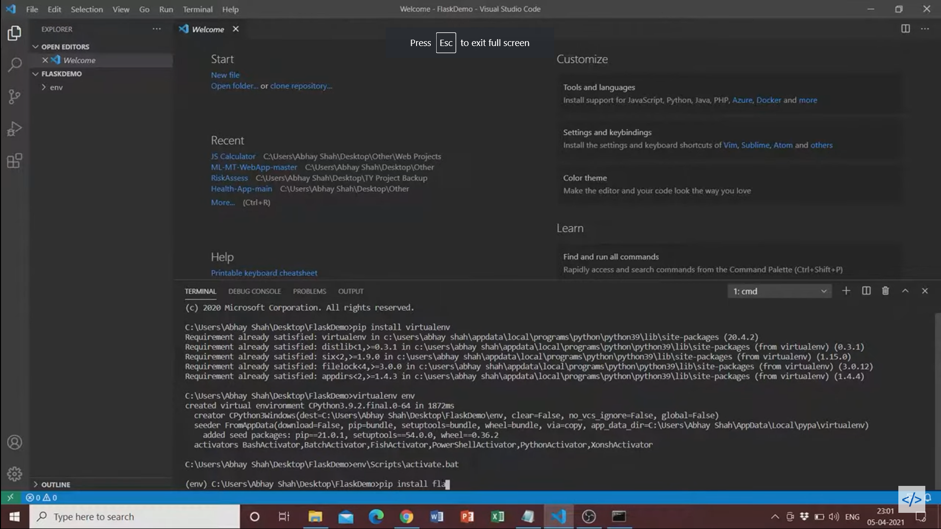

Deploy in Visual Studio

Add all packages to requirements.txt

Create virtual env

To add files from local to azure repo:

Download azure cli if not

az –version 🡪 check if present

Add extention

az extension add --name azure-devops

az login

For seamless commanding, set the organization and project as defaults in configuration.

az devops configure --defaults organization=https://dev.azure.com/snairharikrishnan project=Loan-Default

Cd <location>

Git init

Git add –all

Git commit -m “first commit”

az repos create --name LoanDefault

git remote add origin <https://snairharikrishnan@dev.azure.com/snairharikrishnan/Loan-Default/_git/LoanDefault>

(url will be present under remoteurl key)

git push origin master -f